EMHF
European & Mediterranean
Horseracing Federation

BRUSSELS MISSION 2016

The EMHF’s EU Committee staged its latest mission to the European Parliament and Commission in Brussels on July 12th and 13th. These visits have become a regular, annual feature of the Committee’s work, providing the opportunity to impress on influential EU figures the importance of the Thoroughbred racing sector as part of the wider equine sector and affording EMHF EU member countries a chance to meet with key MEP’s and Commission Officials to discuss matters of interest to the racing industries in their countries.

It was the Racing Authorities of Great Britain and Ireland which fielded delegates this year. The recent ‘Brexit’ decision, of keen interest to both countries, was high on the agenda.

As always, an impressive schedule of interviews was arranged by EMHF EU advisor and Committee member, Cathy McGlynn, who tailored the programme to the particular interests of the delegates present. Meetings were held with, among others, MEP’s Jim Nicholson, Sean Kelly, Vicky Ford and Daniel Dalton; and Dermot Ryan, advisor to Agriculture and Rural Development Commissioner, Phil Hogan.

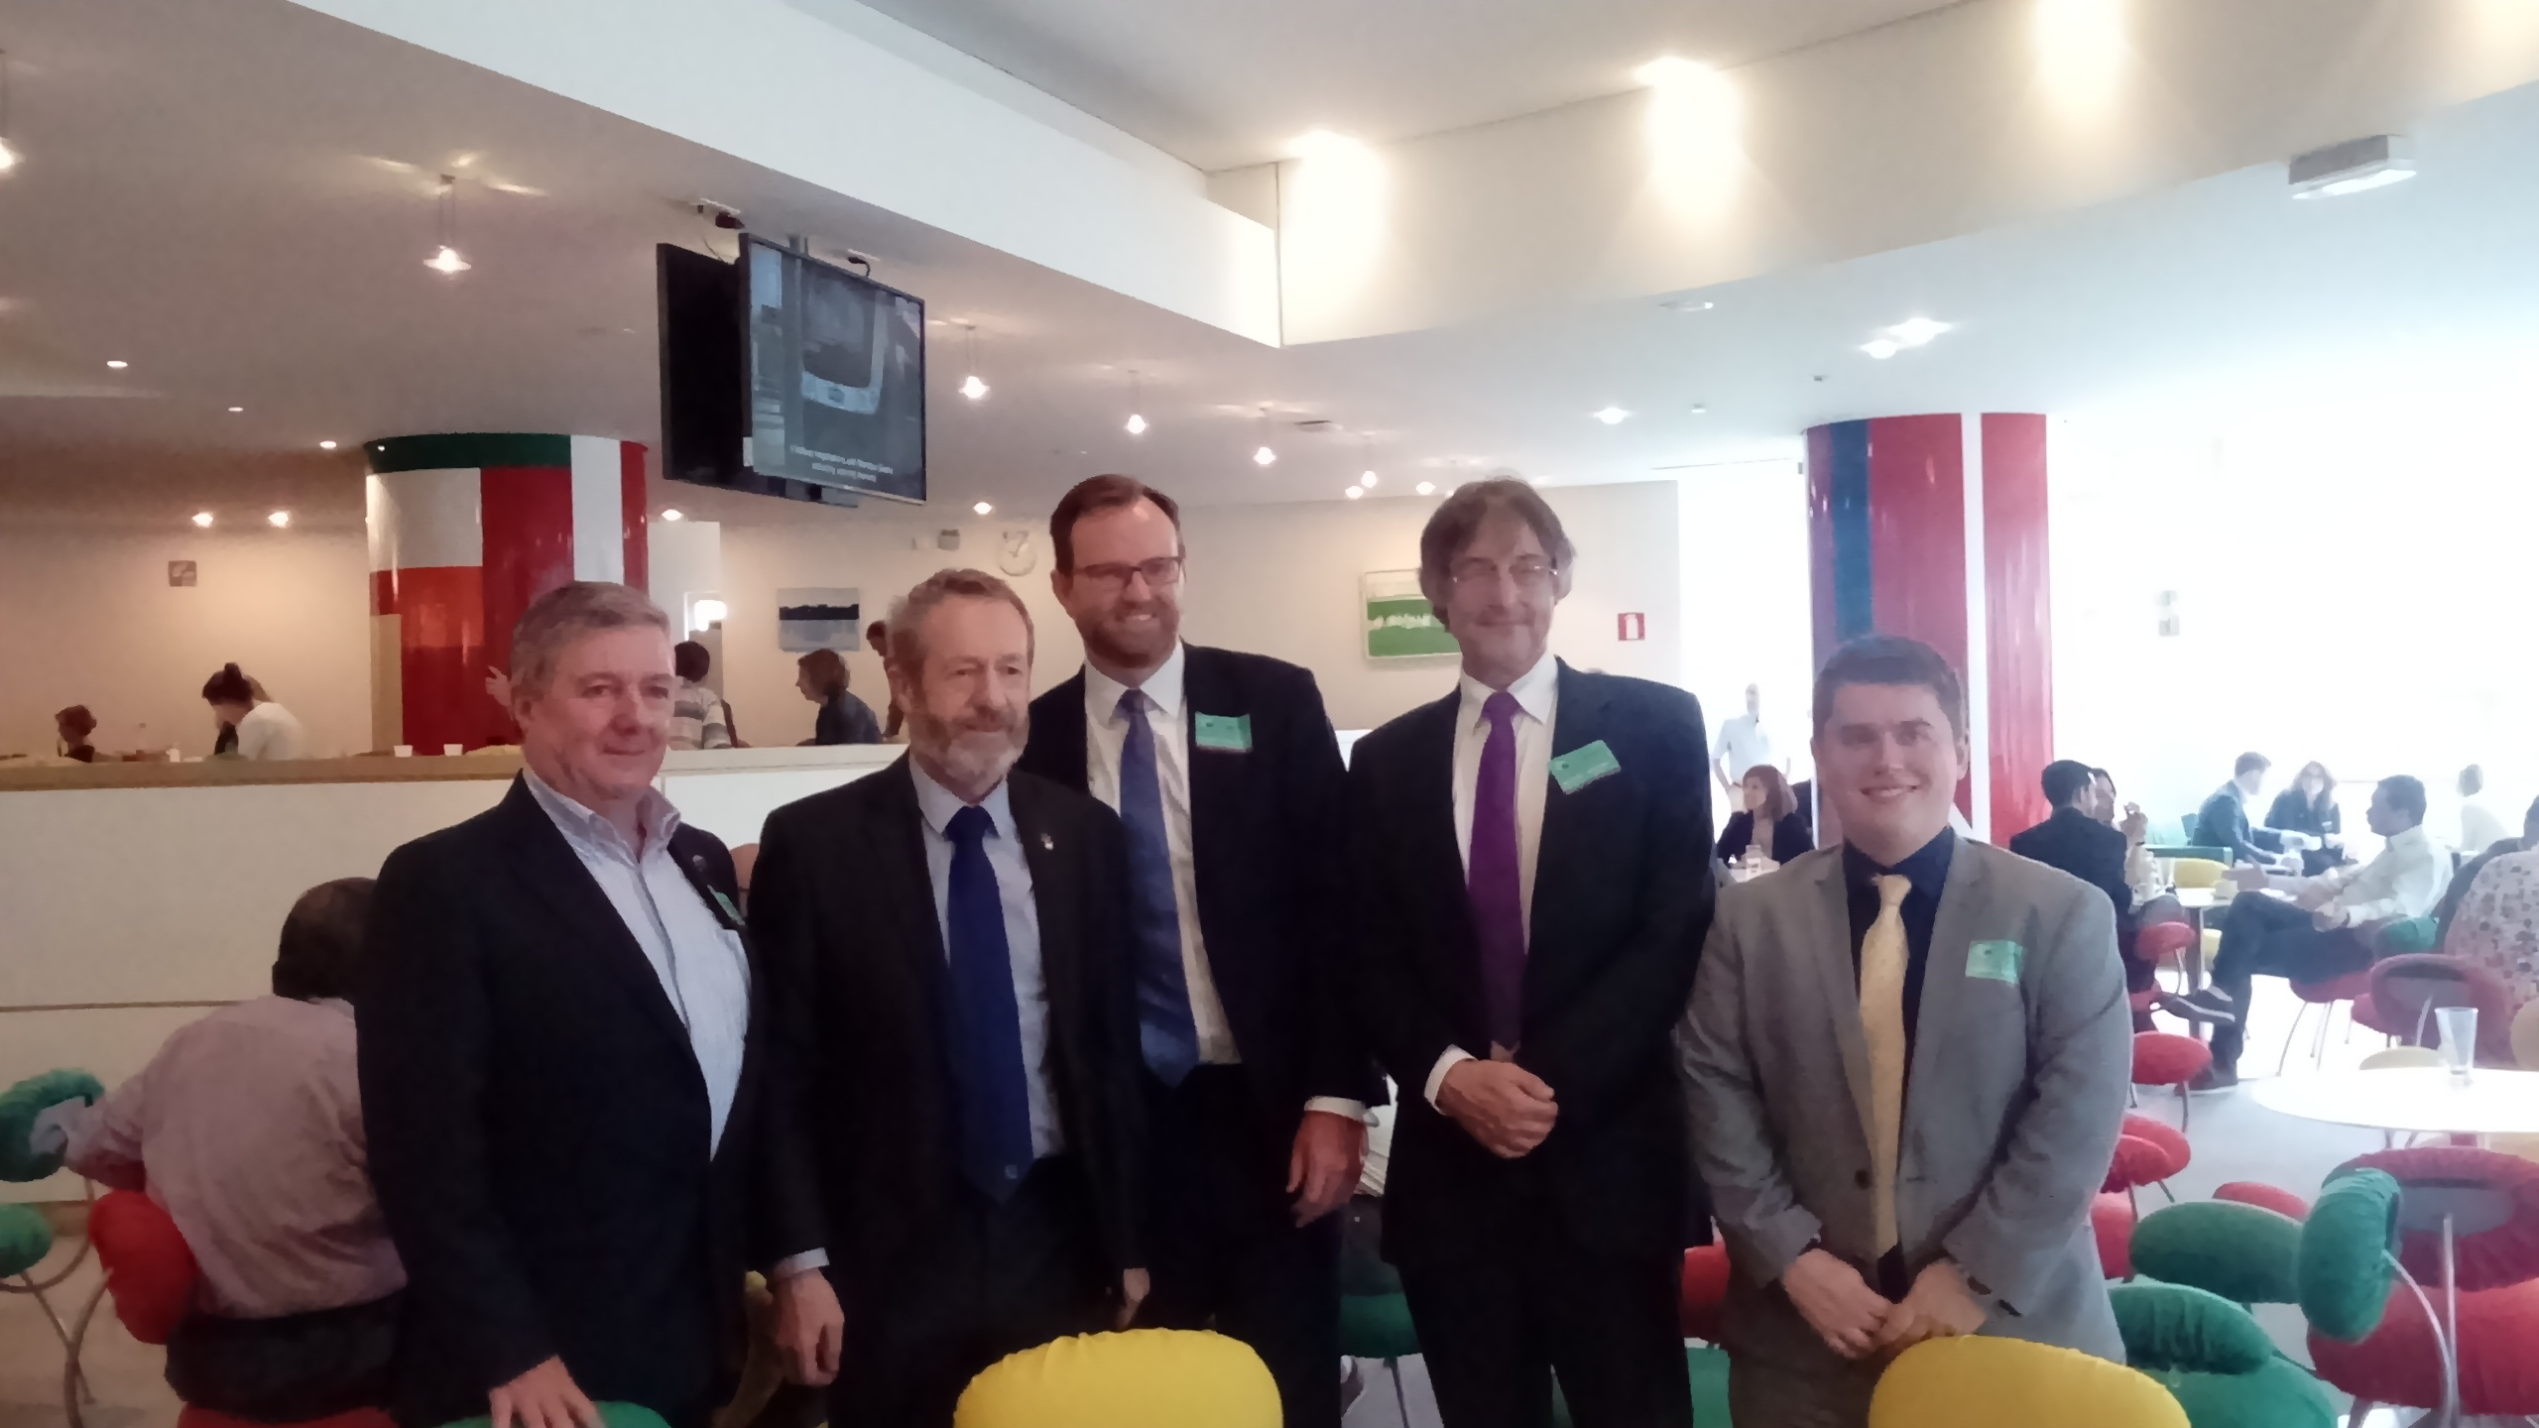
From left: MichaelO’Rourke (Director of Strategy and Marketing, Horse Racing Ireland), Sean Kelly MEP, Will Lambe (Director of Corporate Affairs, British Horseracing Authority), Paull Khan (Secretary-General, EMHF) and Ross Hamilton (External Affairs Officer, BHA), at the European Parliament.

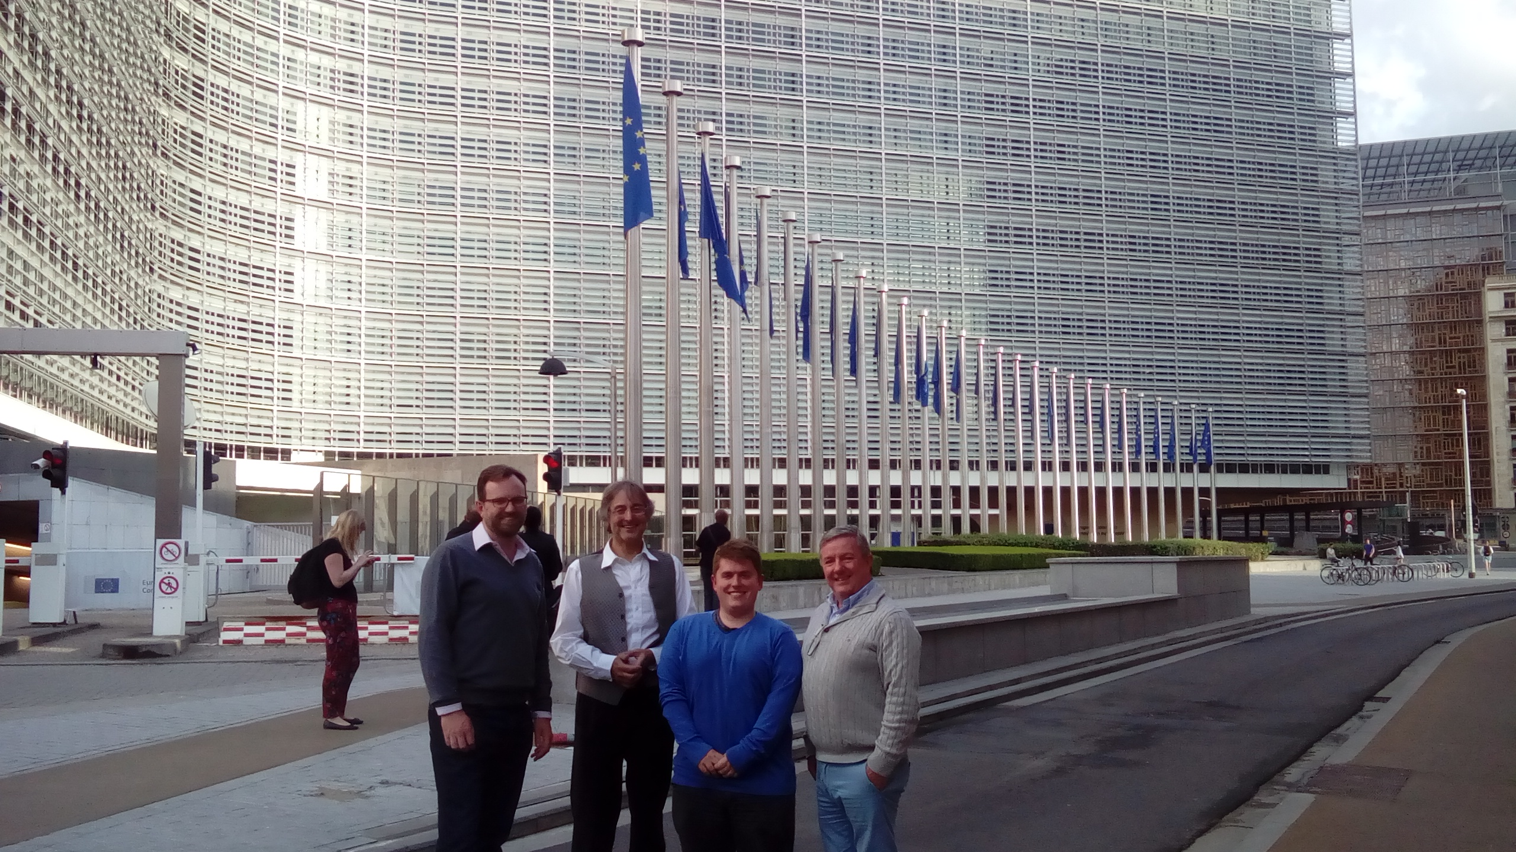

EMHF EU Committee members in front of the European Commission building, Brussels.

Paull Khan, EMHF Secretary-General, said: “The EMHF is on the European Parliament’s and Commission’s Transparency Register, making it much easier to gain valuable access to key decision-makers in Brussels. The EU Committees Brussels annual missions are open to all EMHF EU members, and I look forward to including representatives of other countries next year and discussing issues of particular concern to them.”

